

U.S. DRUG Overdose Death Rates



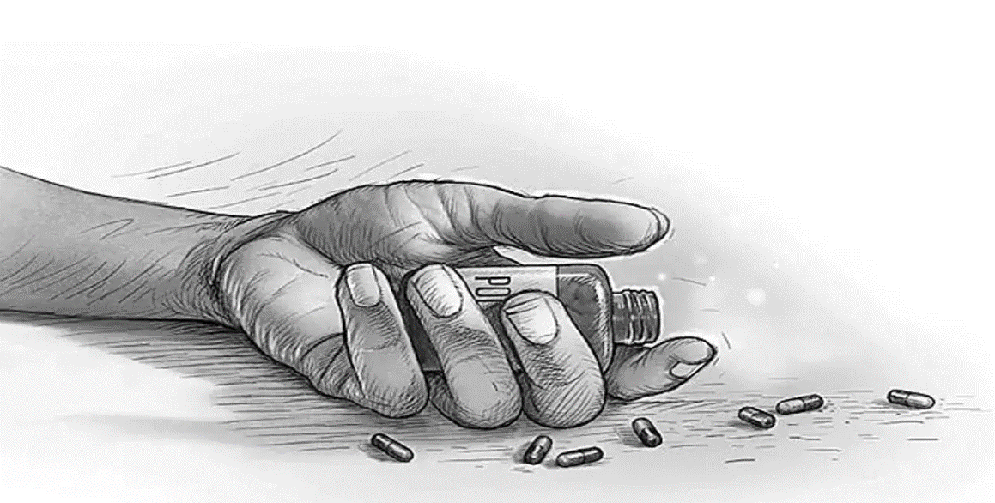

Table of Contents

**Introduction2**

**Project Description3**

Objective**3**

Requirements**3**

Scope of Project and Out of Scope**4**

Outcomes and Benefits**5**

Deliverables**5**

**Team Profiles** **6**

**Execution6**

Resources**6**

Techniques**8**

Execution Process **9**

Process Visualization**11**

Potential Challenges**11**

Timeframe**13**

Project Team**14**

Model Selection**14**

Communication**14**

Scope Creep and Changes**14**

**Code of Conduct15**

Ethical Considerations**15**

Information Management **15**

**Milestones16**

**Conclusion** **17**

### Introduction

The escalating rates of drug overdose deaths in the United States pose a significant societal challenge, impacting individuals, families, and communities. Substance abuse-related fatalities have surged in recent years, necessitating urgent attention and innovative solutions to mitigate this pressing public health crisis.

The Drug Overdose Death Rates Mitigation project aims to analyze, understand, and address the complexities of drug overdose fatalities using advanced data analytics and intervention strategies. By meticulously examining comprehensive datasets related to drug overdose death rates across demographic categories, this project endeavors to devise preventive measures and intervention tactics to curb the rising fatalities.

Key reasons why the people in United States are more addicted drug overdose.

* **Prescription Drug Practices:** Over the past few decades, liberal prescription practices, particularly regarding opioids for pain management, have significantly contributed to the opioid epidemic. Widespread availability and over-prescription of opioid medications have inadvertently led to addiction and subsequent overdose deaths.
* **Accessibility and Availability:** Easy accessibility to prescription medications, combined with illicit drug availability, has fueled the addiction crisis. The presence of illegal drugs in the market, including heroin and synthetic opioids like fentanyl, exacerbates the issue, making addictive substances more readily available.
* **Socioeconomic Factors:** Socioeconomic disparities, including poverty, unemployment, lack of education, and limited access to healthcare, significantly impact substance abuse rates. These factors often lead individuals to seek solace or escape through substance use, contributing to addiction.
* **Cultural and Peer Influence:** Social environments and peer pressure can significantly impact drug use behavior. Cultural acceptance or normalization of drug use in certain communities may contribute to higher rates of addiction and overdose.
* **Insufficient Prevention and Education**: Inadequate public health education and prevention initiatives contribute to a lack of awareness about the risks of drug abuse. Insufficient education about the dangers of substance misuse and overdose limits individuals' ability to make informed decisions.
* **Pain Management Practices**: The pursuit of effective pain management, particularly in healthcare, has inadvertently led to the overprescribing of opioids. Lack of alternative pain management options and the desire to alleviate suffering have played a role in the opioid crisis.

### Project Description

### Objective

* Develop a predictive model for drug overdose rates that accurately forecasts patterns and trends based on historical data analysis.
* Identify key factors contributing to drug overdose rates, considering demographic factors, economic indicators, prescription practices, and types of drugs involved in overdose incidents.
* Provide actionable recommendations to mitigate drug overdose risks, improve prevention strategies, and enhance intervention methods.
* Utilize advanced analytical techniques and machine learning algorithms to identify significant variables impacting drug overdose rates and patterns.
* Enhance public health responses and interventions by incorporating socio-economic, healthcare access, and substance abuse treatment data into the predictive model.

### Requirements

Requirements for the Drug Overdose Analysis project include:

* Analysing historical and real-time data on drug overdose incidents, considering demographics, drug types, geographical locations, and time trends.
* Identifying critical factors contributing to drug overdose rates, encompassing socioeconomic status, prescription practices, mental health diagnoses, and availability of treatment services.
* Presenting visualizations and statistical analyses of drug overdose data to aid policymakers, healthcare professionals, and communities in understanding trends and making informed decisions.
* Allowing customization of input variables and adjustment of prediction parameters to tailor the model to specific geographical regions or demographic characteristics.
* Enabling stakeholders to compare predicted overdose rates with actual reported incidents to assess the effectiveness of preventive measures and intervention strategies.

### Scope of Project and Out of Scope

In Scope Activities:

* Data Collection and Preparation: Gathering and cleaning datasets related to drug overdose incidents, demographics, drug types, geographical locations, and time trends for analysis.
* Exploratory Data Analysis (EDA): Analysing and visualizing data to identify patterns, trends, correlations, and risk factors contributing to drug overdose rates.
* Predictive Modelling: Developing and validating predictive models using machine learning techniques to forecast drug overdose trends and identify at-risk populations.
* Power BI Dashboard Development: Creating interactive and user-friendly Power BI dashboards to present drug overdose data, trends, and predictive insights for stakeholders and decision-makers.
* Documentation and Reporting: Documenting project methodologies, findings, and insights obtained from the analysis, compiling reports for stakeholders, and sharing lessons learned.

Out of Scope Activities:

* Direct Intervention or Treatment: Providing immediate healthcare or treatment services for individuals experiencing drug overdose incidents.
* Legislative or Regulatory Analysis: Conducting extensive analysis of drug-related laws, policies, or regulations governing drug use or prescription practices.
* Financial Services or Transaction Analysis: Offering financial services related to drug transactions or monetary aspects associated with substance abuse.
* Mobile App Development: Creating mobile applications for immediate emergency response or individual substance abuse management.
* Environmental Impact Assessment: Conducting extensive assessments of environmental effects associated with drug production or drug use beyond the scope of analysing overdose rates.

### Outcomes and Benefits

Outcomes

* Accurate predictions of drug overdose rates and patterns, facilitating targeted interventions and resource allocation.
* Enhanced understanding of factors influencing drug overdose incidents for improved mitigation strategies.
* Development of an intuitive and accessible interface for data visualization and analysis of drug overdose trends.
* Improved communication and collaboration among stakeholders involved in addressing drug-related challenges.
* Accessible dashboards presenting drug overdose trends and insights for public health officials and policymakers.
* User-friendly navigation enabling efficient data exploration and analysis for researchers and analysts.

Benefits

* Decreased drug overdose incidents and associated health risks.
* Enhanced public health outcomes and improved quality of life for affected communities.
* Empowered decision-making through evidence-based insights into drug overdose trends.
* Increased efficiency in targeting interventions to high-risk areas or populations.
* Improved understanding of contributing factors leading to drug overdose incidents.

### Deliverables

* Comprehensive report detailing data sources, collection procedures, and data processing methodologies related to drug overdose incidents.
* EDA report showcasing insights and patterns identified within the drug overdose data.
* Report on the development of predictive models, elucidating methodologies and outcomes transparently.
* User manuals and training materials to ensure effective utilization of the analytics solution for stakeholders.
* An intuitive data visualization and analysis interface for exploring drug overdose trends and patterns.

### Team Profiles

|  |  |  |
| --- | --- | --- |
| Name | Main Role | Experience Skill |
| Jahir Khan | Team Leader | * Strong Knowledge in Python, Machine learning. * Internship on Web development (ReactJs, CSS, backend, PHP) |
| Darshan Tahiliani | Developer | * critical thinking * Adaptability * Teamwork * Communication |
| Rohan Juneja | Presenter | * leadership * Time management * Negotiation * Decision making |

### Execution

Resource Allocation:

In the realm of analyzing drug overdose rates in the United States, the quality and diversity of data sources are fundamental in shaping our insights and strategic interventions. The essential data required for this project includes, but isn't limited to:

* Drug Overdose Incident Data: This encompasses historical records and real-time data on drug overdose incidents across different regions and demographic groups. The data should include details such as types of drugs involved, geographical locations, demographics of affected individuals, and trends over time.
* Prescription and Substance Use Data: Information about prescriptions, substance abuse patterns, and drug usage statistics is crucial. This includes data on prescribed medications, illicit drug use, and overdose incidents related to specific substances.
* Socio-demographic Factors: Understanding socio-economic and demographic elements that influence drug overdose rates is vital. Data on population demographics, income levels, education, employment rates, and access to healthcare resources will be integral for comprehensive analysis.
* Healthcare System Data: Access to healthcare services, treatment facilities, availability of overdose reversal medications (e.g., naloxone), and the effectiveness of intervention programs are essential components for evaluation.
* Continuous Maintenance of Data Quality: Ensuring the accuracy, relevance, and consistency of the collected data throughout the project duration is critical for building reliable predictive models and deriving actionable insights.

IT Infrastructure:

The technological infrastructure is pivotal in facilitating the analysis and processing of extensive data for comprehending drug overdose rates in the United States. We need to consider two primary components:

* Data Storage Solution: A robust, secure, and scalable data storage solution will be pivotal for this project. It may involve utilizing cloud-based or on-premises storage, depending on the client's preferences, existing infrastructure, data volume, and security requirements.
* Data Processing and Analytics Tools: Optimal data processing and analytics tools are crucial for effective analysis. Employing cutting-edge tools aligned with the project's objectives will ensure efficient data cleaning, processing, analysis, and visualization.

Personnel:

The success of this project heavily relies on a proficient and specialized team equipped to handle the unique challenges associated with analyzing drug overdose rates.

* Data Analysts: Skilled data analysts will spearhead the collection, cleansing, and analysis of extensive datasets related to drug overdose incidents. Their expertise will be pivotal in deciphering intricate patterns and trends necessary for constructing meaningful predictive models.
* IT Specialists: This specialized team will be responsible for crafting, maintaining, and securing the IT infrastructure essential for data storage, processing, and analysis. Their role will ensure the reliability, security, and efficiency of the technological backbone.
* Project Managers: The project management team will oversee logistics, resource allocation, and ensure efficient collaboration among team members. They will maintain project timelines and ensure that objectives are met within defined parameters.

# Techniques

To comprehensively understand and tackle drug overdose rates in the United States, we will employ a series of advanced techniques, including:

* Data Cleaning and Processing: Foundational to our analysis, this technique ensures data reliability by cleaning and refining datasets. It involves eliminating discrepancies, handling missing or irrelevant data, and formatting the information for effective analysis.
* Exploratory Data Analysis (EDA): EDA techniques will be crucial in uncovering patterns, correlations, and outliers in drug overdose data. This process involves statistical analysis and visualizations to derive insights that guide subsequent steps.
* Predictive Modeling: Leveraging machine learning algorithms, we will build predictive models using historical and real-time data to forecast and analyze trends in drug overdose rates. These models will assist in foreseeing potential patterns and trends, aiding in proactive intervention and policy-making.
* Data Visualization: Visual representation of complex data will be achieved through sophisticated visualization techniques. Interactive dashboards and visualizations will help stakeholders comprehend and interpret the analysis, facilitating informed decision-making.

# Tools

To execute these techniques effectively, we will utilize a suite of cutting-edge tools tailored to our objectives:

* Statistical Analysis Tool: Python, a versatile programming language, will serve as our primary tool for statistical analysis and predictive modeling. Its extensive libraries and capabilities enable robust analysis and model development
* Data Visualization Tool: Power BI or Tableau will be employed for data visualization, offering dynamic and user-friendly representations of drug overdose trends. Its interactive dashboards will enable stakeholders to grasp complex data effortlessly.
* Data Storage and Management: For efficient storage and management of extensive datasets, we will might utilize SQL databases. These databases provide scalability, security, and seamless access to structured data.
* Machine Learning Models: Various machine learning algorithms such as logistic regression, decision trees, and clustering algorithms will be employed to build predictive models that forecast drug overdose trends accurately.

By integrating these advanced techniques and tools, we aim to provide a comprehensive analysis of drug overdose rates in the United States. This data-driven approach will empower decision-makers and healthcare professionals to implement targeted interventions and policies to mitigate drug-related crises effectively.

## Execution Process

Effectively addressing the rising issue of drug overdose rates in the United States necessitates a structured approach. The execution process will involve the following key steps:

1. Requirements and Contextual Understanding:

* Initiate comprehensive discussions with stakeholders to define the project's scope, objectives, and expected outcomes.
* Gain a deep understanding of the specific regions affected, prevailing drug abuse patterns, and the primary drivers contributing to drug overdoses.

1. Data Collection and Integration:

* Gather diverse data from multiple sources, including CSV files of medical records, public health databases, law enforcement reports, and demographic information.
* Organize and integrate collected CSV data securely using file storage solutions or cloud-based storage services.

1. Data Preprocessing and Cleaning:

* Rigorously clean and preprocess the collected CSV data to ensure accuracy and consistency.
* Address missing values, standardize formats, and remove redundancies to prepare the data for analysis.

1. Data Analysis and AI Modeling:

* Utilize statistical analysis techniques and machine learning algorithms in Python to analyze the CSV data and identify significant trends and patterns.
* Develop predictive models using Python-based libraries to forecast and predict potential drug overdose trends and risk factors based on historical data.

1. Data Visualization:

* Leverage visualization tools such as Matplotlib, Seaborn, or Plotly and Power BI to create interactive visualizations and reports showcasing the analyzed data.

1. Intervention Strategy Development:

* Develop targeted intervention strategies and policy recommendations based on the insights derived from the CSV data analysis and predictive models.
* Collaborate with healthcare professionals, policymakers, and relevant stakeholders to design effective prevention and treatment programs.

1. Implementation and Monitoring:

* Implement the recommended strategies and interventions, continually monitoring their effectiveness.
* Adjust and fine-tune strategies based on ongoing data analysis and feedback to optimize impact.

1. Continuous Learning and Adaptation:

* Develop adaptive models capable of learning from the dataset provide by data.gov and adjusting predictions as trends evolve.
* Ensure continuous improvement of models to reflect the changing landscape of drug abuse patterns.

1. AI Model Integration:

* Integrate AI models into the project framework to enhance predictive capabilities.

1. Secure Data Management:

* Employ secure data management practices, ensuring compliance with privacy regulations and safeguarding sensitive information in the dataset provide by data.gov.

By following this structured execution process and utilizing advanced analytics and intervention strategies based on dataset provide by data.gov, we aim to provide data-driven solutions that contribute to the reduction of drug overdose rates in the United States. This approach empowers decision-makers and healthcare professionals to implement targeted interventions and policies effectively.

## Process Visualization

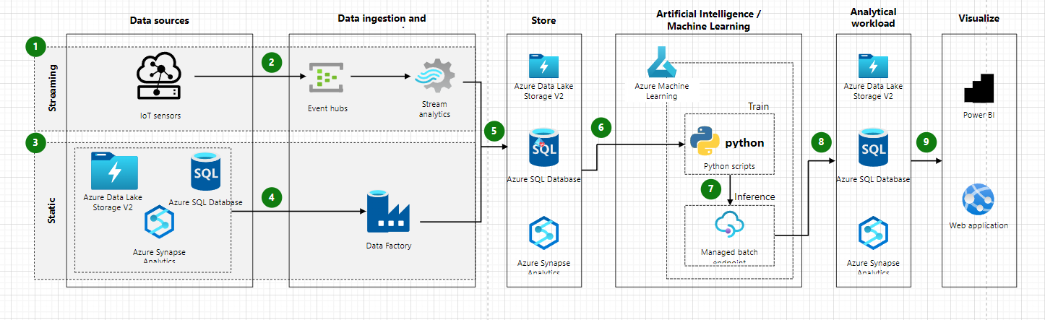

## Potential Challenges

* Data Aggregation: Collecting diverse datasets related to drug abuse, including medical records, law enforcement reports, and demographic information, may pose challenges in integrating disparate sources and ensuring data consistency and reliability.
* Data Volume and Quality: Managing extensive datasets regarding drug abuse and overdose incidents, especially in regions with high substance abuse rates, might strain computational resources. Ensuring data quality and reliability is crucial for accurate analysis.
* Data Privacy and Compliance: Handling sensitive information related to individuals' health records and drug-related incidents demands stringent measures to comply with privacy laws (e.g., HIPAA) and ensure data anonymization.
* Model Complexity and Interpretability: Developing accurate predictive models for drug overdose rates requires accounting for multifaceted factors such as demographics, drug trends, and socio-economic indicators. Ensuring model transparency and interpretability is crucial for gaining stakeholder trust.
* Stakeholder Engagement: Collaboration with healthcare professionals, law enforcement agencies, and policymakers may face challenges due to differing priorities, regulatory hurdles, and organizational barriers.
* Ethical Considerations: Addressing ethical concerns, including fairness and bias in analysing drug-related datasets, to ensure equitable interventions and prevent marginalized community targeting.
* Public Perception and Stigma: Overcoming societal stigma associated with drug addiction to garner public support and engagement for preventive and treatment initiatives might pose a challenge.
* Resource Limitations: Budget constraints and resource limitations might hinder the implementation of comprehensive interventions and limit the scope of data analysis and preventive measures.
* Intervention Effectiveness: Ensuring the effectiveness of proposed interventions and treatment strategies requires ongoing monitoring and adaptation, which might face obstacles due to varying community responses and external factors.
* Policy Implementation: Navigating regulatory environments and advocating for policy changes to support evidence-based interventions and drug abuse prevention measures can be complex and time-consuming.

## Risk and Issues Management

U.S. DRUG OVERDOSE DEATH RATES project, effective risk management is critical to ensure project success. The key risks identified include data quality issues, model performance concerns, resource constraints, and privacy/security considerations.

* Data Quality Risk: Potential challenges may arise regarding the accuracy and completeness of drug-related datasets. To mitigate this, robust data validation processes and quality checks will be implemented. Regular audits and validation measures will ensure data accuracy throughout the project lifecycle.
* Model Performance Risk: There is a risk of model inefficiency due to the evolving nature of drug abuse patterns and demographic shifts. To counter this, a strategy for continual model evaluation, retraining, and adaptation to changing trends will be established. Regular assessments of model performance metrics will guide necessary updates.
* Resource Constraints Risk: Insufficient budget or computational resources might impact the project's effectiveness. Mitigation measures will include evaluating resource utilization, adjusting budget allocation as needed, and developing contingency plans to manage resource limitations.
* Privacy and Security Risk: Handling sensitive health-related data poses privacy and security risks. Mitigation will involve implementing robust data encryption, access controls, and compliance with stringent privacy laws (e.g., HIPAA). Regular security audits and compliance checks will be conducted.

Managing issues effectively is crucial to maintaining project momentum and achieving project objectives. Identified issues in the U.S. DRUG OVERDOSE DEATH RATES project include data collection delays, technical challenges, regulatory compliance issues, and resource allocation delays.

* Data Collection Delays: In case of delays in acquiring necessary drug-related datasets, alternative data acquisition strategies will be explored to ensure continuity in analysis and modeling processes.
* Technical Challenges: Immediate action will be taken to address any unforeseen technical obstacles encountered during data processing or model development. Technical experts will be tasked with promptly resolving these issues to prevent significant project disruptions.
* Regulatory Compliance Issues: Collaborating with legal experts will ensure adherence to healthcare and privacy regulations governing the handling of sensitive medical information. Regular updates on regulatory changes will inform necessary adjustments to maintain compliance.
* Resource Allocation Delays: Efforts will be made to streamline resource allocation processes, and clear communication channels will be maintained with resource providers to prevent delays in acquiring essential project resources.

By proactively managing these risks and addressing potential issues, the project aims to maintain its momentum, ensure data accuracy, uphold privacy regulations, and deliver effective strategies to combat drug addiction and reduce overdose rates in the United States.

## Timeframe

The Team will exercise its best efforts to respect deadlines and deliver the anticipated objectives.

## Project Team

## Our project team comprises seasoned professionals well-versed in pertinent fields critical for the successful execution of this initiative. We are dedicated to delivering top-tier results within the project timeline and adhering to allocated resources. While we aim for seamless execution, we acknowledge the potential for unforeseen challenges and commit to maintaining open lines of communication with the client. Should unexpected circumstances arise, we'll swiftly strategize alternative measures to ensure project continuity.

## Model Selection

## The project places significant emphasis on selecting the most effective model to achieve optimal outcomes. In case of any challenges or issues with the initially chosen model, our team will conduct a comprehensive assessment within the constraints of time and resources. If the current model is deemed inadequate, we'll prioritize finding a suitable alternative. Transparent communication with the client will be upheld throughout this process, with timely updates regarding any potential impact on project timelines. Our commitment remains strong in selecting and implementing the most appropriate model for project success.

## Communications

## The collaboration and support of the client are integral to project success. We highly value the client's dedication to the project's objectives and their readiness to provide additional resources as required. Maintaining an open and collaborative communication channel between our team and the client is crucial for aligning with project goals. Our commitment is to ensure effective communication, enabling seamless project progress and prompt addressing of any emerging needs or opportunities.

## Scope Creep and Changes

# Our approach involves meticulously defining and documenting the project scope, encompassing objectives, timelines, deliverables, and resource prerequisites. We've implemented a robust change control process to manage any scope alterations, ensuring comprehensive documentation, impact assessment, and client notifications. Detailed documentation of project requirements mitigates ambiguity. Upon encountering scope changes, we conduct thorough impact assessments encompassing timelines, resources, budgets, and associated risks. The client is actively engaged throughout, with transparent communication upheld. Informed recommendations, based on impact assessments, are presented for client decision-making, guaranteeing project focus, alignment with client expectations, and overall project success while minimizing scope-related challenges.

# Code of Conduct

## Ethical Considerations

* We acknowledge our strict duty of confidentiality.
* We will ensure the observance of ethical practices demonstrating respect, honesty and dignity.
* We will thoroughly follow the Client's directives without deviation from the objectives.
* Value is always present in our thinking.
* Validated data will solely form the basis of our observations, conclusions, recommendations and decision-making.
* We undertake to use holistic analytics strategies and repeatable processes.
* We will thoroughly explain and document our analysis in detail for the Client. We will be transparent in all our activities.
* Moreover, we will check and recheck our research for quality, accuracy, completeness and integrity before presentation to maintain the validity and credibility of the results.
* We will proactively circumvent unethical behavior, such as exaggerating the results of our research.
* We will not falsely interpret, fabricate, embellish or otherwise misrepresent the data to validate our findings or change or omit details favoring making an analysis fit a hypothesis.
* We will be forthright and accountable if we make mistakes.
* We will tell the truth, even if it is bad news.
* Failure to observe deadlines is considered a breach of ethics.
* We have no conflict of interest and will not benefit from this Project.

## Information Management

* We acknowledge that the data is an asset of any organization. The consequences and repercussions of unethical conduct when dealing with an organization's data can be significant and affect an organization's reputation, relationships and, ultimately, its revenues. Even the perception of unethical data handling has the power to undermine both internal and external trust.
* We give assurance that all the information provided is in our trust. It will remain private and protected from damage or alteration unless authorized.
* We will sign a Non-Disclosure Agreement that is acceptable to the Client and adhere to its conditions.
* We will notify the Client of the discovery of any sensitive information at any stage, namely personal identifying information or confidential information. We will make recommendations for addressing the issues and act according to their instructions.
* Original data and other information entrusted to us is stored in a secure location, such as SharePoint, and will remain unaltered.
* Copies of original data will be used for cleaning, discovery, manipulation and analysis.
* Naming conventions and version controls will segregate documentation, datasets and work product. Each will align with the applicable phase of the Project.
* All work will only be conducted through secure applications.
* All our workstations are protected by a password that is unknown to anyone other than the assigned user. No one has access to our workstations, including colleagues, family members and friends.
* All information sharing is secured from potential risks using encrypted channels, such as SharePoint.
* Discussions about the data, analysis and observations will only be amongst client-authorized collaborators and our course instructors.
* All information entrusted to us will only be used for its intended purposes unless specifically approved by the Client.

# Milestones

|  |  |
| --- | --- |
| **Milestone** | **Complete By** |
| Acceptance of Project Charter | 2023/12/07 |
| Requirements Phase | 2023/12/07 |
| Data Collection & Reporting | 2024/01/21 |
| Forecasting Model Design | 2024/02/28 |
| Testing Phase | 2024/03/08 |
| Release Phase | 2024/03/27 |
| Client Presentation | 2024/04/19 |
| Handover of the Deliverables Phase | 2024/04/19 |
| Project Close-Out Phase | 2024/04/23 |

# Conclusion

Our initiative tackling drug overdose deaths has been a dedicated endeavor. Beginning with clear objectives and innovative data analysis, we've made strides in understanding and combating drug addiction complexities.

Our predictive models have provided valuable insights, guiding interventions to mitigate overdose rates, enhance addiction treatment strategies, and identify crucial patterns and trends. Collaboration and transparent communication with our client have been instrumental throughout the project's duration. We've remained aligned with the client's objectives, addressing challenges collaboratively and adapting our strategies to meet evolving needs.

Concluding this project, our commitment remains steadfast in providing data-driven recommendations. Our reports ensure lasting knowledge for stakeholders in combating this crisis. This initiative marks a significant step in addressing drug overdose deaths.

We thank our client for their trust. This project has been a journey of determination and innovation. We eagerly anticipate future opportunities to further contribute to reducing this critical public health issue."